Materials and Properties

Before selecting certain material we should consider its properties like:-

* Strength
* Stiffness
* Density
* Ductility
* Fatigue resistance
* Cost of material
* Cost of machining and working

Properties depends on purpose of which the machine is intended.

Different types of materials used in the modern era

* **Steel**

Steel, either as tube or sheet, depending on design. There are several reasons for its choice

* Raw material cost is relatively low
* Well developed manipulating and joining techniques are available
* Young’s modulus is high, so the requested stiffness can be obtained with small tube sizes

Steels have competitive advantages over light weight alloys and composites not only with regard to material cost, but also with respect to manufacturing cost.

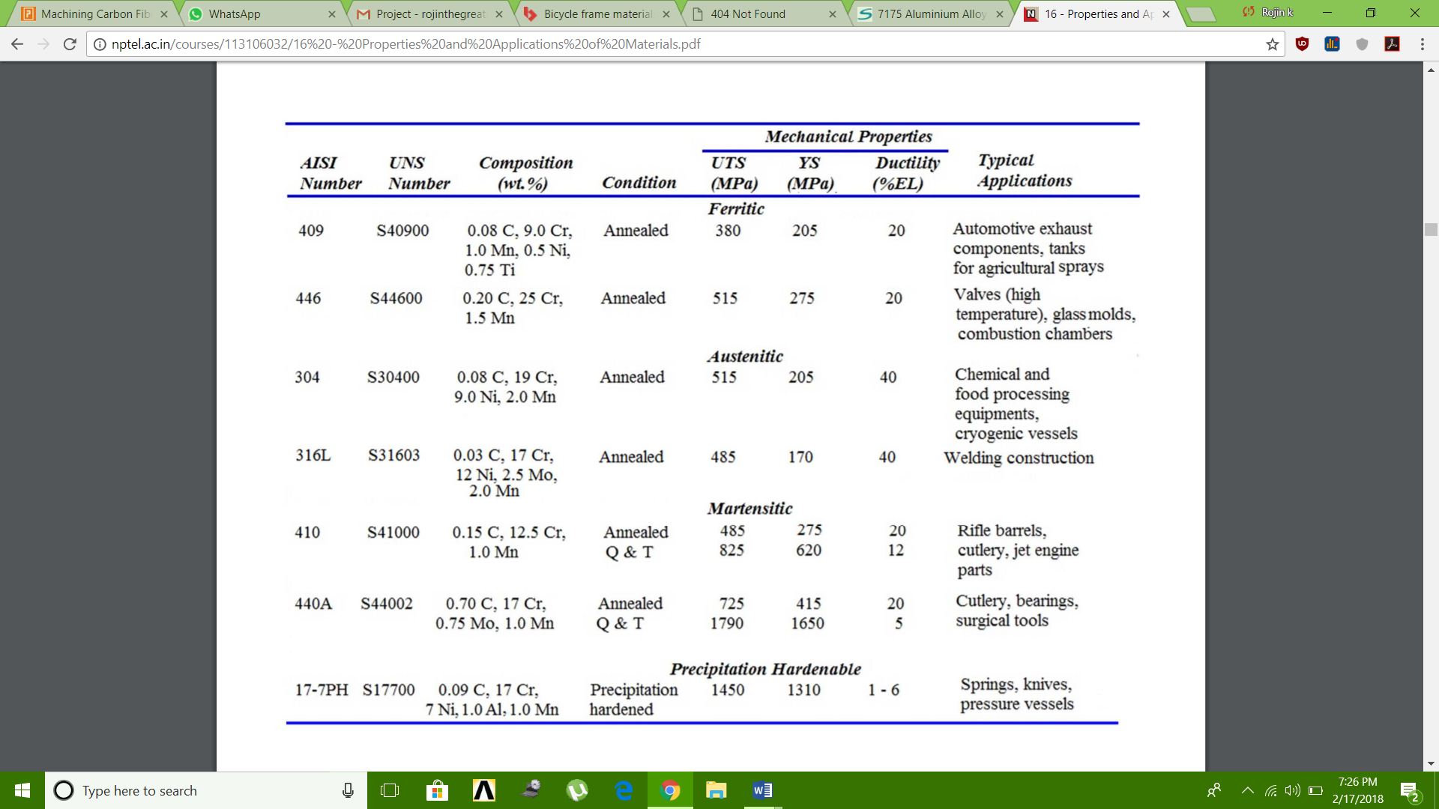

* **Aluminium**

**Aluminium is lighter than steel, durable enough for its structural purpose, very workable and above all, affordable.**

One of the best known properties of aluminium is that it is light, with a density one third that of steel, 2,700 kg/m3. The low density of aluminium accounts for it being lightweight but this does not affect its strength.

**Strength**

Aluminium alloys commonly have tensile strengths of between 70 and 700 MPa. The range for alloys used in extrusion is 150 – 300 MPa. Unlike most steel grades, aluminium does not become brittle at low temperatures. Instead, its strength increases. At high temperatures, aluminium’s strength decreases.

**Formability**

Aluminium’s superior malleability is essential for extrusion. With the metal either hot or cold, this property is also exploited in the rolling of strips and foils, as well as in bending and other forming operations.

**Joining**

Features facilitating easy jointing are often incorporated into profile design. Fusion welding, Friction Stir Welding, bonding and taping are also used for joining.

**Corrosion resistance**

Anodising increases the thickness of the oxide layer and thus improves the strength of the natural corrosion protection. Where aluminium is used outdoors, thicknesses of between 15 and 25 ¥ìm (depending on wear and risk of corrosion) are common.

Aluminium is extremely durable in neutral and slightly acid environments.  
In environments characterized by high acidity or high basicity, corrosion is rapid.

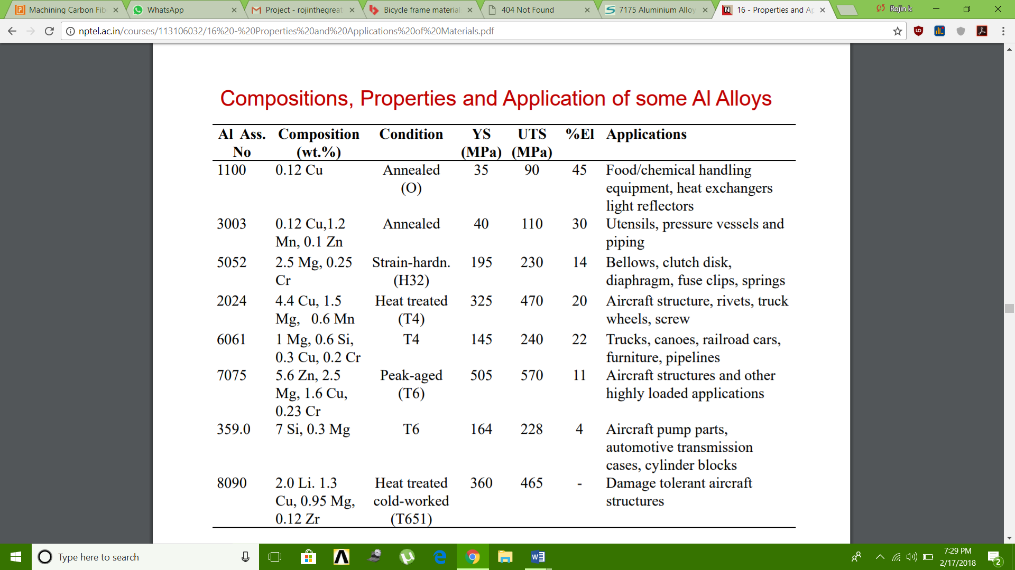

* **Carbon fibre**

Carbon fibers have several advantages including high stiffness, high tensile strength, low weight, high chemical

resistance, high temperature tolerance and low thermal expansion

Its creation starts with eight lengths of ‘pultruded’ carbon-fibre.

Pultrusion is a method of making long tubes or strips out of carbon-fibre, where the woven or braided fibres are pulled through a bath of resin and then a heated die which cures the resin and forms the shape of the tubing, which can then be cut to the desired length.

Property of  PEEK 450CA40 Polyetheretherketone, 40% Carbon Fibre Reinforced

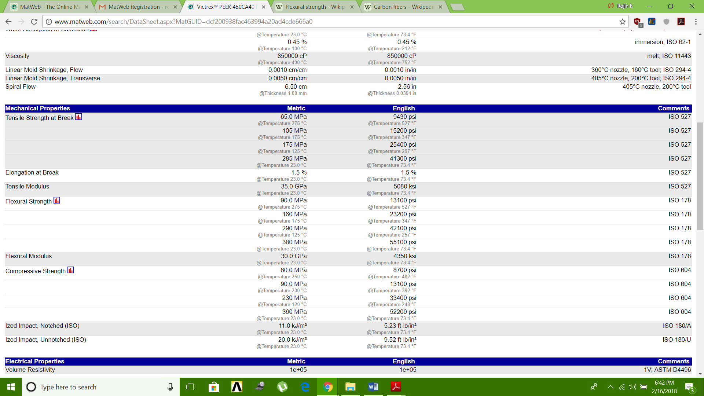

* **Magnesium**

Magnesium can be used to engineer bike frames that [are lighter than aluminum](https://mmta.co.uk/2016/06/01/materials-selection-in-bicycles/) while maintaining high tensile strength and damping capabilities. All of that leads to a much smoother, more efficient ride. Magnesium also comes in at a lower price point than popular lightweight materials like carbon fiber.

Property chart of magnesium

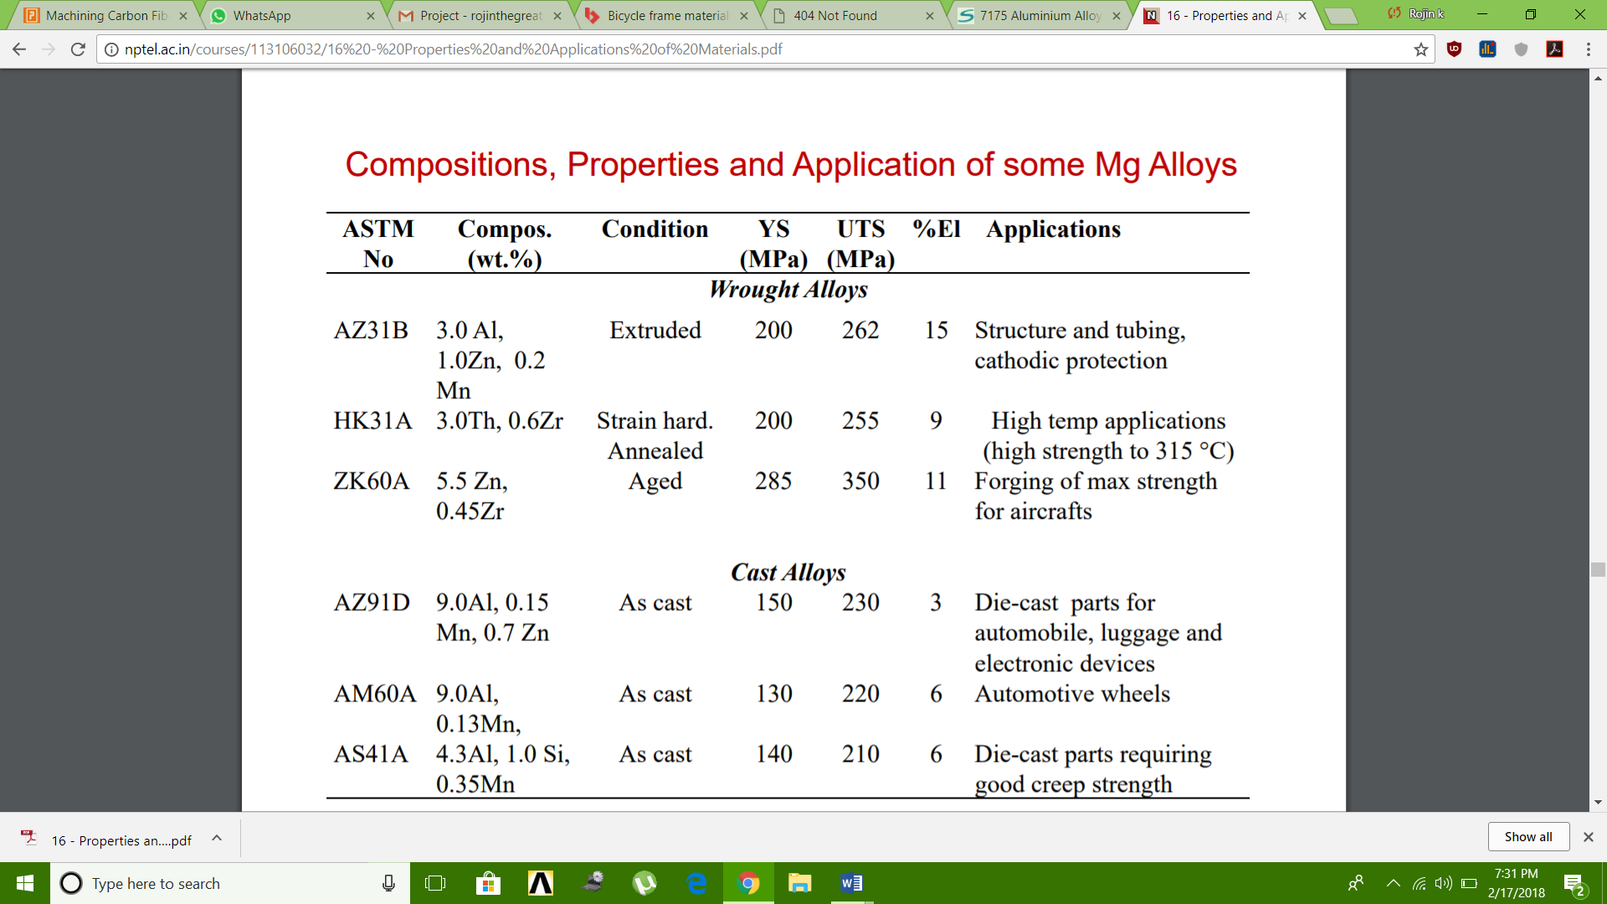

* **Titanium**
* As a [metal](https://en.wikipedia.org/wiki/Metal), titanium is recognized for its high [strength-to-weight ratio](https://en.wikipedia.org/wiki/Strength-to-weight_ratio).
* It is a strong metal with low [density](https://en.wikipedia.org/wiki/Density) that is quite [ductile](https://en.wikipedia.org/wiki/Ductility).
* Commercially pure (99.2% pure) [grades](https://en.wikipedia.org/wiki/Titanium_alloy#Grades_of_titanium) of titanium have [ultimate tensile strength](https://en.wikipedia.org/wiki/Ultimate_tensile_strength) of about 434 [MPa](https://en.wikipedia.org/wiki/Megapascal) (63,000 [psi](https://en.wikipedia.org/wiki/Pounds_per_square_inch)), equal to that of common, low-grade steel alloys, but are less dense.
* Titanium is 60% denser than aluminium, but more than twice as strong as the most commonly used [6061-T6 aluminium alloy](https://en.wikipedia.org/wiki/6061_aluminium_alloy). Certain titanium alloys (e.g., [Beta C](https://en.wikipedia.org/wiki/Titanium_Beta_C)) achieve tensile strengths of over 1,400 MPa (20,0000 psi).
* Titanium is not as hard as some grades of heat-treated steel;
* Like steel structures, those made from titanium have a [fatigue limit](https://en.wikipedia.org/wiki/Fatigue_limit) that guarantees longevity in some

applications.

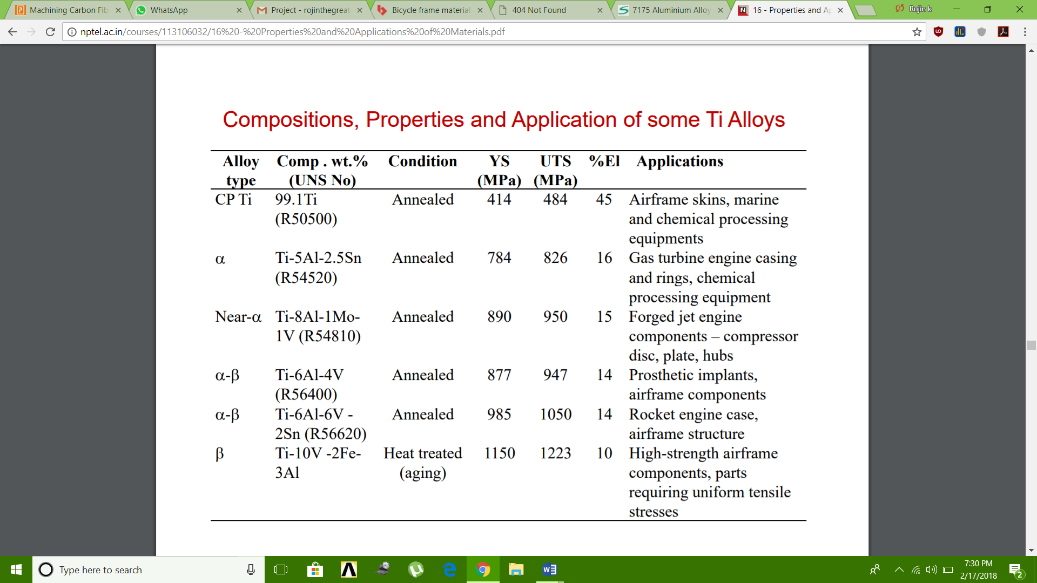

Cost of different materials per KG

1. **Steel**

Structural Sections and Beams Rebar Merchant Bar

Rate(Rs) 32300 30500 31400

1. **Aluminium**

|  |  |  |
| --- | --- | --- |
| **Aluminium Type** | **Rate** | **Units** |
| MCX Aluminium Futures | 139.65 | paise per kilogram |
| MCX Aluminium Mini Futures | 139.70 | paise per kilogram |

1. **Titanium**

Grade TI-6-4 BAR

CURRENT PRICE: 3540/kg

1. **Magnesium**

Magnesium alloys

Current Price : 3000/kg

1. **Carbon fibre**

Machinability of different materials

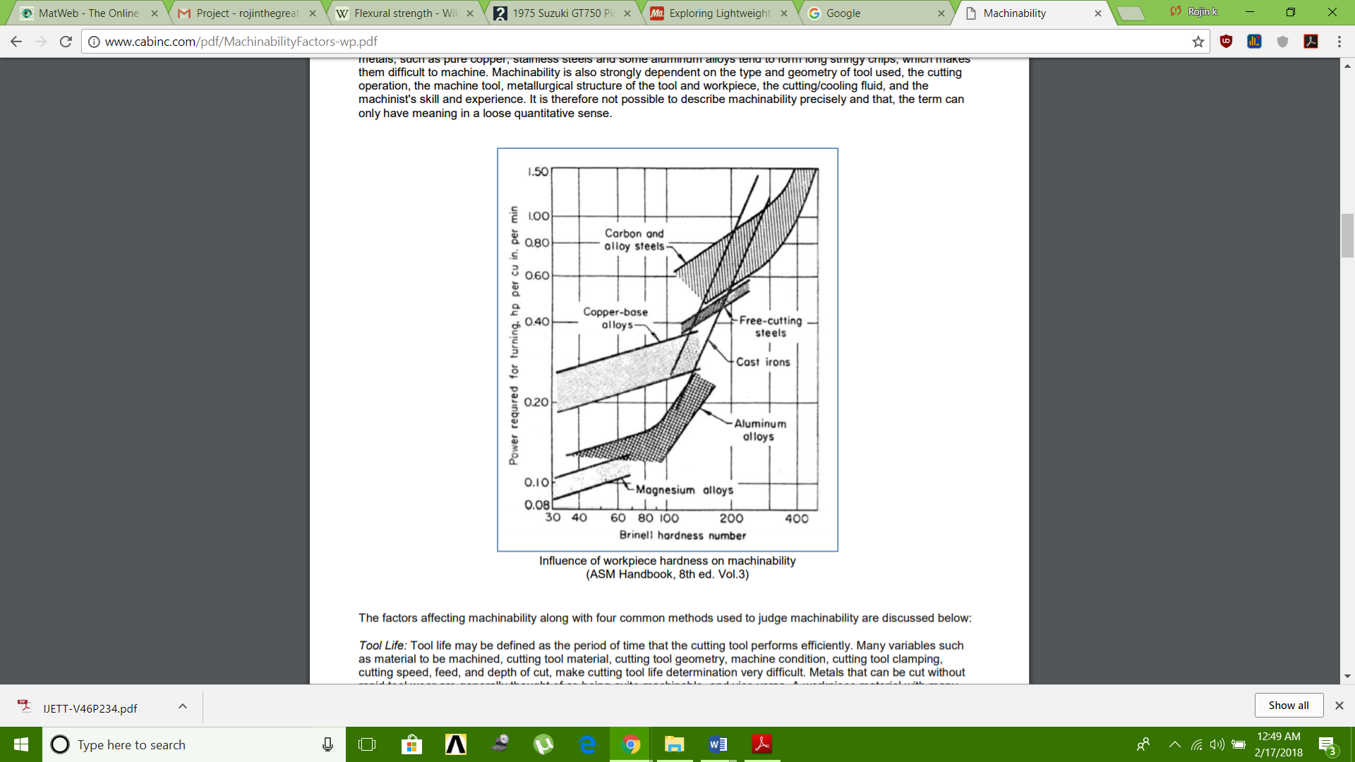

1. Steel

Machinability of medium carbon steels depends to a large extent on their microstructure. They machine best when they have the coarse pearlite or spheroidized carbide structure. Steels with carbon content in excess of 0.6% machine best in the fully spheroidized condition. As a general rule, tool wear rates increase in a consistent manner as the carbon content of work material is increased beyond 0.35%.

In general, surface finish improves with increasing carbon content up to 0.35%, however, the surface finish depends

not only on carbon content but also on the cutting operation, the tool geometry and the cutting conditions.

1. Aluminium

Aluminium is easily worked using most machining methods – milling, drilling, cutting, punching, bending, etc. Furthermore, the energy input during machining is low.

Aluminum is very easy to machine, although the softer grades tend to form edge build-up resulting in poor surface finish. Thus, high cutting speeds, high rake angles, and high relief angles are recommended. Wrought aluminum alloys with high silicon content and cast aluminum alloys are abrasive; hence, they require harder tool materials. Controlling dimensional tolerances may be a problem in machining of aluminum because it has a high thermal expansion coefficient and a relatively low elastic modulus.

1. Titanium

Titanium and its alloys have very poor thermal conductivity (the lowest of all metals), causing a significant temperature rise and built-up edge. They are highly reactive and can be difficult to machine.

1. Magnesium

Magnesium is the lightest structural metal and exhibits excellent machinability. Some of the advantages of machining magnesium compared to other commonly used metals include: • Low power required – approximately 55% of that required for Al.

• Fast machining – employing the use of high cutting speeds, large feed rates and greater depths of cut

. • Excellent surface finish – extremely fine & smooth surface achieved.

• Well broken chips – due to the free-cutting qualities of magnesium.

• Reduced tool wear – leading to increased tool life.

To fully exploit and enjoy the advantages of machining magnesium, it is important that the unique characteristics of the metal are understood.

1. Carbon fibre

Material Selection

1. **Aluminium Alloy 6061 t4**

T4 temper 6061 has an [ultimate tensile strength](https://en.wikipedia.org/wiki/Ultimate_tensile_strength) of at least 210 MPa (30,000 psi) and yield strength of at least 110 MPa (16,000 psi). It has elongation of 16%.

Material Composition

|  |  |  |  |  |  |  |  |  |  |  |  |  |  |  |  |  |  |  |  |  |  |  |  |  |  |  |  |  |  |  |  |  |  |  |  |  |  |  |  |  |  |  |  |  |  |  |  |  |  |  |  |  |  |
| --- | --- | --- | --- | --- | --- | --- | --- | --- | --- | --- | --- | --- | --- | --- | --- | --- | --- | --- | --- | --- | --- | --- | --- | --- | --- | --- | --- | --- | --- | --- | --- | --- | --- | --- | --- | --- | --- | --- | --- | --- | --- | --- | --- | --- | --- | --- | --- | --- | --- | --- | --- | --- | --- |
| |  |  |  | | --- | --- | --- | | **Component** | **Wt. %** | http://asm.matweb.com/images/spacer.gif | | |  | | --- | | http://asm.matweb.com/images/spacer.gif | | | | Al | 95.8 - 98.6 |  | | Cr | 0.04 - 0.35 |  | | Cu | 0.15 - 0.4 |  | | Fe | Max 0.7 |  | | |  |  |  | | --- | --- | --- | | **Component** | **Wt. %** | http://asm.matweb.com/images/spacer.gif | | |  | | --- | | http://asm.matweb.com/images/spacer.gif | | | | Mg | 0.8 - 1.2 |  | | Mn | Max 0.15 |  | | Other, each | Max 0.05 |  | | Other, total | Max 0.15 |  | | |  |  |  | | --- | --- | --- | | **Component** | **Wt. %** | http://asm.matweb.com/images/spacer.gif | | |  | | --- | | http://asm.matweb.com/images/spacer.gif | | | | Si | 0.4 - 0.8 |  | | Ti | Max 0.15 |  | | Zn | Max 0.25 |  | |

Material properties

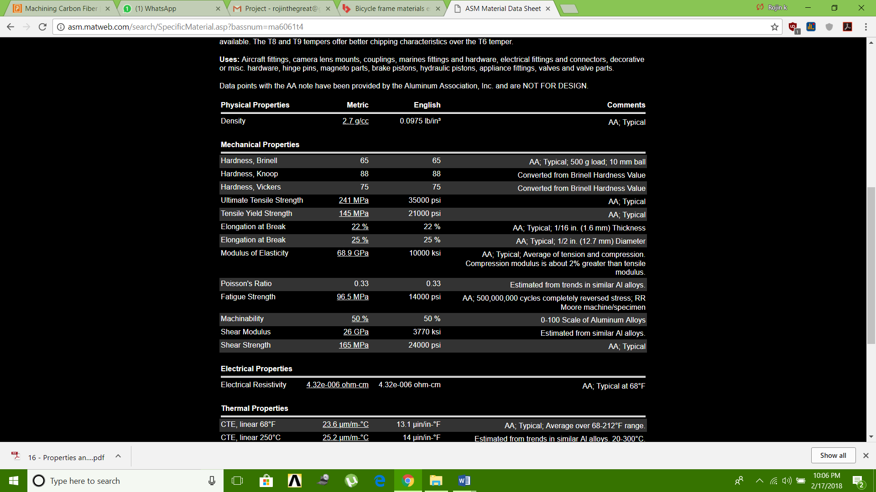

1. **Aluminium Alloy 6061 t6**

T6 temper 6061 has an ultimate tensile strength of at least 290 MPa (42,000 psi) and yield strength of at least 240 MPa (35,000 psi).

Material Composition

|  |  |  |  |  |  |  |  |  |  |  |  |  |  |  |  |  |  |  |  |  |  |  |  |  |  |  |  |  |  |  |  |  |  |  |  |  |  |  |  |  |  |  |  |  |  |  |  |  |  |  |  |  |  |
| --- | --- | --- | --- | --- | --- | --- | --- | --- | --- | --- | --- | --- | --- | --- | --- | --- | --- | --- | --- | --- | --- | --- | --- | --- | --- | --- | --- | --- | --- | --- | --- | --- | --- | --- | --- | --- | --- | --- | --- | --- | --- | --- | --- | --- | --- | --- | --- | --- | --- | --- | --- | --- | --- |
| |  |  |  | | --- | --- | --- | | **Component** | **Wt. %** | http://asm.matweb.com/images/spacer.gif | | |  | | --- | | http://asm.matweb.com/images/spacer.gif | | | | Al | 95.8 - 98.6 |  | | Cr | 0.04 - 0.35 |  | | Cu | 0.15 - 0.4 |  | | Fe | Max 0.7 |  | | |  |  |  | | --- | --- | --- | | **Component** | **Wt. %** | http://asm.matweb.com/images/spacer.gif | | |  | | --- | | http://asm.matweb.com/images/spacer.gif | | | | Mg | 0.8 - 1.2 |  | | Mn | Max 0.15 |  | | Other, each | Max 0.05 |  | | Other, total | Max 0.15 |  | | |  |  |  | | --- | --- | --- | | **Component** | **Wt. %** | http://asm.matweb.com/images/spacer.gif | | |  | | --- | | http://asm.matweb.com/images/spacer.gif | | | | Si | 0.4 - 0.8 |  | | Ti | Max 0.15 |  | | Zn | Max 0.25 |  | |

Material Properties

|  |  |  |  |
| --- | --- | --- | --- |
| **Physical Properties** | **Metric** | **English** | **Comments** |
| |  | | --- | | http://asm.matweb.com/images/spacer.gif | | | | |
| Density | [2.7 g/cc](http://asm.matweb.com/search/GetUnits.asp?convertfrom=43&value=2.7) | 0.0975 lb/in³ | AA; Typical |
| **Mechanical Properties** | | | |
| |  | | --- | | http://asm.matweb.com/images/spacer.gif | | | | |
| Hardness, Brinell | 95 | 95 | AA; Typical; 500 g load; 10 mm ball |
| Hardness, Knoop | 120 | 120 | Converted from Brinell Hardness Value |
| Hardness, Rockwell A | 40 | 40 | Converted from Brinell Hardness Value |
| Hardness, Rockwell B | 60 | 60 | Converted from Brinell Hardness Value |
| Hardness, Vickers | 107 | 107 | Converted from Brinell Hardness Value |
| Ultimate Tensile Strength | [310 MPa](http://asm.matweb.com/search/GetUnits.asp?convertfrom=79&value=45) | 45000 psi | AA; Typical |
| Tensile Yield Strength | [276 MPa](http://asm.matweb.com/search/GetUnits.asp?convertfrom=79&value=40) | 40000 psi | AA; Typical |
| Elongation at Break | [12 %](http://asm.matweb.com/search/GetUnits.asp?convertfrom=138&value=12) | 12 % | AA; Typical; 1/16 in. (1.6 mm) Thickness |
| Elongation at Break | [17 %](http://asm.matweb.com/search/GetUnits.asp?convertfrom=138&value=17) | 17 % | AA; Typical; 1/2 in. (12.7 mm) Diameter |
| Modulus of Elasticity | [68.9 GPa](http://asm.matweb.com/search/GetUnits.asp?convertfrom=79&value=10000) | 10000 ksi | AA; Typical; Average of tension and compression. Compression modulus is about 2% greater than tensile modulus. |
| Notched Tensile Strength | [324 MPa](http://asm.matweb.com/search/GetUnits.asp?convertfrom=109&value=324) | 47000 psi | 2.5 cm width x 0.16 cm thick side-notched specimen, Kt = 17. |
| Ultimate Bearing Strength | [607 MPa](http://asm.matweb.com/search/GetUnits.asp?convertfrom=109&value=607) | 88000 psi | Edge distance/pin diameter = 2.0 |
| Bearing Yield Strength | [386 MPa](http://asm.matweb.com/search/GetUnits.asp?convertfrom=109&value=386) | 56000 psi | Edge distance/pin diameter = 2.0 |
| Poisson's Ratio | 0.33 | 0.33 | Estimated from trends in similar Al alloys. |
| Fatigue Strength | [96.5 MPa](http://asm.matweb.com/search/GetUnits.asp?convertfrom=124&value=14000) | 14000 psi | AA; 500,000,000 cycles completely reversed stress; RR Moore machine/specimen |
| Fracture Toughness | [29 MPa-m½](http://asm.matweb.com/search/GetUnits.asp?convertfrom=111&value=29) | 26.4 ksi-in½ | KIC; TL orientation. |
| Machinability | [50 %](http://asm.matweb.com/search/GetUnits.asp?convertfrom=138&value=50) | 50 % | 0-100 Scale of Aluminum Alloys |
| Shear Modulus | [26 GPa](http://asm.matweb.com/search/GetUnits.asp?convertfrom=45&value=26) | 3770 ksi | Estimated from similar Al alloys. |
| Shear Strength | [207 MPa](http://asm.matweb.com/search/GetUnits.asp?convertfrom=79&value=30) | 30000 psi | AA; Typical |
|  |  |  |  |

**Comparison between Aluminium 6061 T4 and 6061 T6**

|  |  |  |
| --- | --- | --- |
| **Mechanical Properties** | Al 6061 T4 | Al 6061 T6 |
| Brinell Hardness | 63 | 93 |
| Elastic (Young's, Tensile) Modulus, GPa 69 | 69 | 69 |
| Elongation at Break, % | 18 | 10 |
| Fatigue Strength, MPa | 96 | 96 |
| Poisson's Ratio | .33 | .33 |
| Shear Modulus, GPa | 26 | 26 |
| Shear Strength, MPa | 170 | 210 |
| Tensile Strength: Ultimate (UTS), MPa | 230 | 310 |
| Tensile Strength: Yield (Proof), MPa | 130 | 270 |
|  |  |  |
|  |  |  |